# SW520D Vibration Switch

## Introduction

The ball switch, also called the bead switch, the steel ball switch, in fact, is a kind of vibration switch. It has different names but the working principle remains the same. The rolling beads control the connection or disconnection of the circuit by contact the pin or not. To put it simply, just like turning on or off the lights, the lamp will be on if the switch touches the metal plate inside, while the switch leaves, the lamp will be off. Contacting with the metal terminal or changing the travel path of light with small beads in the switch will be able to produce the effect of conduction or not.

The ball switch is widely used, such as: tire pressure monitoring system (TPMS), pedal lights, digital photo frame rotation, flip video camera, anti-theft system, etc. The common ball switches in the market are SW-200D, SW-300DA, SW-520D models, etc. The switch used in this experiment is SW-520D which is OFF in the resting state. When it is subjected to an external touch force which reaches the proper vibration, or the moving speed generates appropriate centrifugal force, conductive pins will instantly be ON state, change the electrical characteristic. When the external force disappears, the electrical characteristic will return to OFF state.

## Product Features

1. non directional, any angle can trigger.

2. fully sealed package, waterproof and dustproof.

3. suitable for small current circuit trigger.

4. dual pin, contact more stable

5. sensitive, sealed, 12V 0.1mA, turn-on time 0.1ms, open circuit impedance 10M, temperature tolerance 105. (Vibration switch is divided into high sensitive, sensitive, standard type, slow type, this switch is sensitive.)

6. diameter 4.5mm, length 11mm.

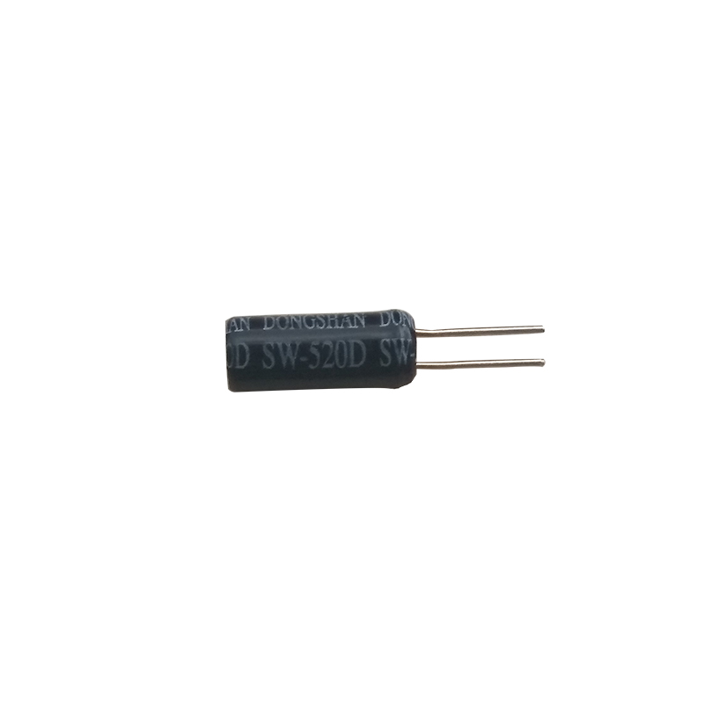

## Experiment Principle

SW-520D is a vibration sensor based on the principle of spring swing, the end of the spring causes resonance due to vibration potential energy, left and right swing touches the metal outer wall forming a circuit path. When the switch is still, any angle is OFF. When it is subjected to external forces or vigorously shaking, spring will deform and contact the center electrode, the two pins will instantly shift to the ON state. When the external force disappears, the circuit will be back to the OFF state.

## Experiment Purpose

The aim is to learn how SW-520D vibration sensor works, and how to use Arduino to control SW-520D vibration sensor.

## Component List

* Keywish Arduino UNO R3 mainboard
* Breadboard
* USB cable
* SW-520D vibration sensor*1
* LED *1
* 10kΩ resistor*1
* Some wires

## Wiring of Circuit

|  |  |
| --- | --- |
| Arduino UNO | SW520D |
| A5 | 1 |
| GND | 2 |

|  |  |
| --- | --- |
| Arduino UNO | 10kΩ resistor |
| 5V | 1 |
| A5 | 2 |

|  |  |
| --- | --- |
| Arduino UNO | LED |
| 13 | + |
| GND | — |

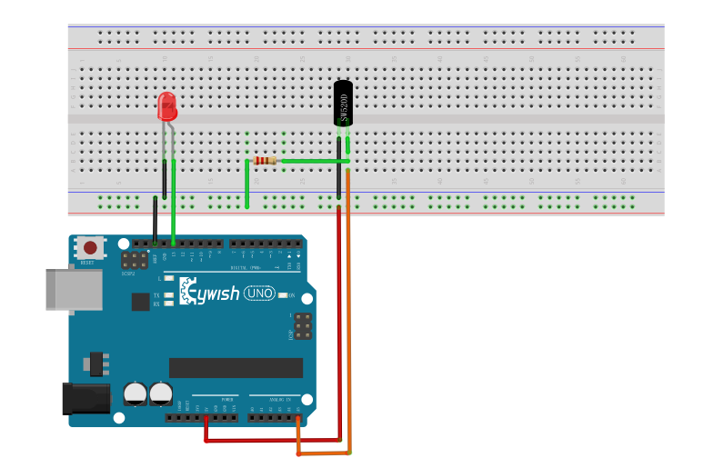

## Code

#include <LiquidCrystal.h>

#include <dht11.h>

#define DHT11PIN 8

dht11 DHT11**;**

// initialize the library with the numbers of the interface pins

LiquidCrystal lcd**(**12**,** 11**,** 5**,** 4**,** 3**,** 2**);**

void setup**()** **{**

pinMode**(**DHT11PIN**,**OUTPUT**);**

// set up the LCD's number of columns and rows:

lcd**.**begin**(**16**,** 2**);**

**}**

void loop**()** **{**

int chk **=** DHT11**.**read**(**DHT11PIN**);**

lcd**.**setCursor**(**0**,** 0**);**

lcd**.**print**(**"Tep: "**);**

lcd**.**print**((**float**)**DHT11**.**temperature**,** 2**);**

lcd**.**print**(**"C"**);**

// set the cursor to column 0, line 1

// (note: line 1 is the second row, since counting begins with 0):

lcd**.**setCursor**(**0**,** 1**);**

// print the number of seconds since reset:

lcd**.**print**(**"Hum: "**);**

lcd**.**print**((**float**)**DHT11**.**humidity**,** 2**);**

lcd**.**print**(**"%"**);**

delay**(**200**);**

**}**

## Experiment Result

